اسم المشروع:

محاكاة مصعد من ثلاث طوابق

أسماء المتدربين وروابط صفة موقع GitHub

1. أحمد علي عايد الجهني

الرقم الأكاديمي :438211979

رابط صفحة GitHub



1. عامر عطيوي الجهني

الرقم الأكاديمي: 439131506

رابط صفحة GitHub



1. اياد طالب محمد عساف

الرقم الأكاديمي:134362270

رابط صفحة GitHub

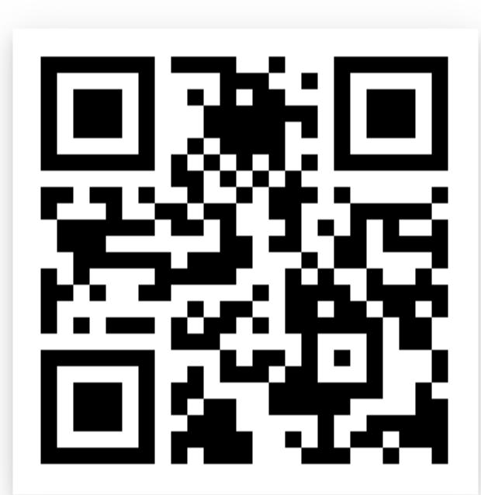

شرح مبسط لفكرة عمل المشروع بشكل شامل

الفكرة الرئيسية هي التنقل من دور الى دور اخر ومحاكاه لدور بالاضاءة لمعرفة موقع الدور.

1. 1وجود 6 سوتشات
2. 3منها لاختيار الدور بحركة تدريجية
3. 3 منها لاستدعاء كل دور
4. العناصر الإلكترونية الأساسية في المشروع

* مصدر ضوئي مصنوع من مواد اشباه الموصلات  تبعث الضوء حينما يمر خلاله **تيار**  كهربائي

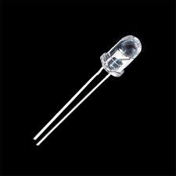

* هي قطعه ذات خاصية فيزيائية تهدف الى اعتراض او اعاقة التيار الكهربائي العالي عبرها

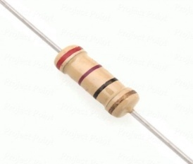

* مفتاح الدفع (الضغط)هو مفتاح فتح لحظي و الذي يسبب تغير موقت في الدائرة الكهربائية عندما يكون المفتاح مدفوع فيزئيا.

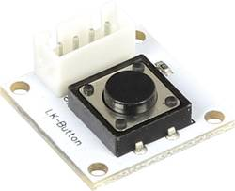

* المعالج هو العقل المدبر للمشروع يستقبل الأوامر ويعالجها ويعطينا نتائج .
* 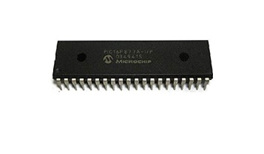نوع البك المستخدم في المشروع PIC16F77A

1. خطوات تنفيذ المشروع مدعومة بالصور

1بناء الدائرة على برنامجDipTrace

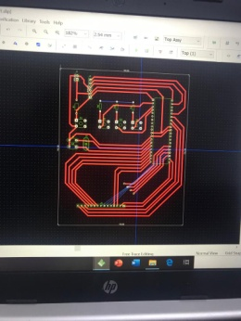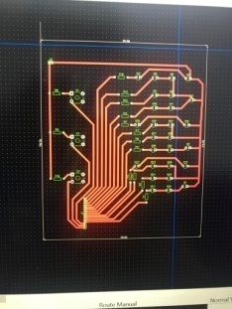1 2

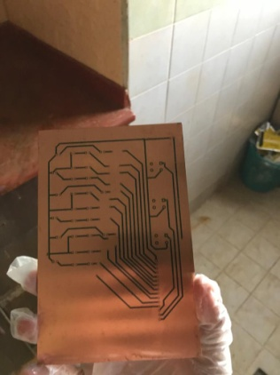 2 طباعة الدائرة الألكترونية على PCB

3تحميض الدائرة

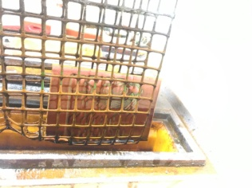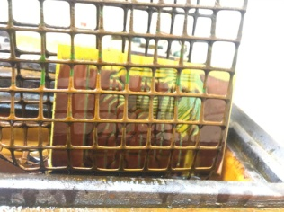 1 2

4تنظيف وتخريم الدائرة المطبوعة

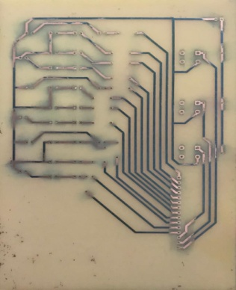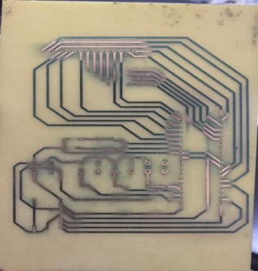 1 2

5تركيب العناصر الموجودة في الدائرة

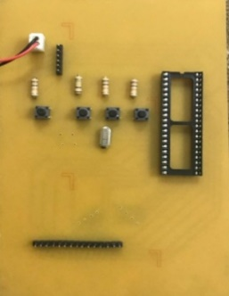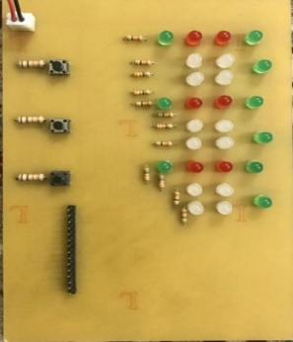 1 2

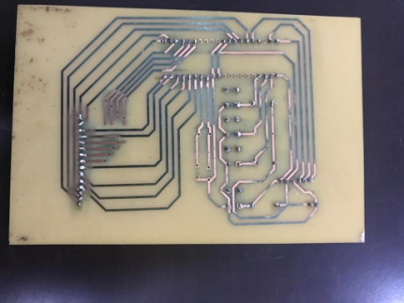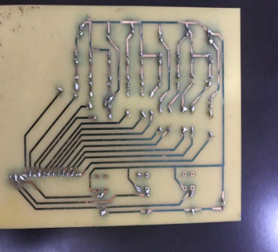 6تلحيم العناصر الموجودة في الدائرة.

7 كتابة كود المشروع

1 2

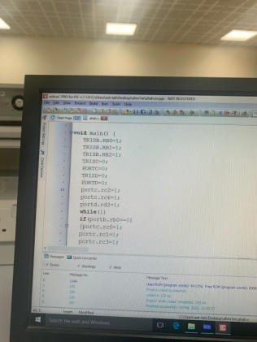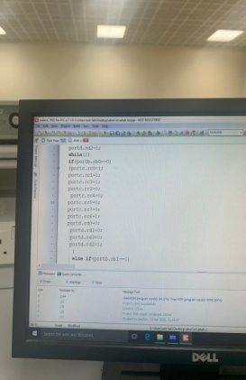

8اختبار الكود البرمجي وتطبيق الدائرة على المحاكاة

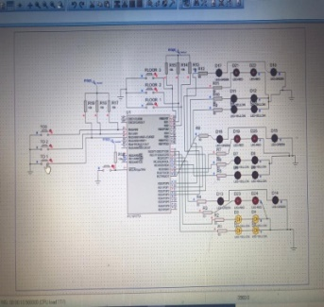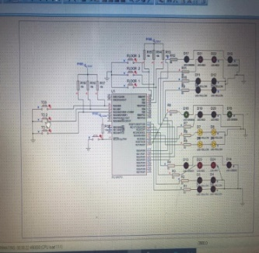 1 2

1. مقترحات تطويريه للمشروع

وجود شاشة LCD بحيث تبين مكان الدور بارقام ووجود جمله ترحيبيه بعد فتح الباب

1. الكود البرمجي

void main() {

trisC=0b00000000; PORTC=0;

TRISD=0b00000000;PORTD=0;

trise=0b00000000;

trisb=0b11111111;

trisa=0b11111111;

adcon1=0b00000110;

portc=0b00000111;

while (1)

{

//3333333333ddddd3333333333//

if(portB.RB0==0&& portc.rc0==1) //FROM 1 TO 3

{portC = 0b01000101;

portd =0b00000100;

delay_ms(1000);

portC = 0b01000110;

portd =0b00000100;

delay_ms(1000);

portC = 0b01010100;

portd =0b00000100;

delay_ms(1000);

portC = 0b01100100;

portd =0b00000100;

delay_ms(1000);

portC = 0b01000100;

portd =0b00000101;

delay_ms(1000);

portC = 0b01000100;

portd =0b00001011;

delay_ms(3000);

portC = 0b01000100;

portd =0b00000111;

}

else if(portB.RB0==0&& portc.rc4==1) //FROM 2 TO 3

{

portC = 0b01010100;

portd =0b00000100;

delay_ms(1000);

portC = 0b01100100;

portd =0b00000100;

delay_ms(1000);

portC = 0b01000100;

portd =0b00000101;

delay_ms(1000);

portC = 0b01000100;

portd =0b00000111;

delay_ms(1000);

portC = 0b01000100;

portd =0b00001011;

delay_ms(3000);

portC = 0b01000100;

portd =0b00000111;

}

else if(portB.RB0==0&& portd.rd0==1) //FROM 3 TO 3

{

portC = 0b01000100;

portd =0b00000111;

delay_ms(1000);

portC = 0b01000100;

portd =0b00001011;

delay_ms(3000);

portC = 0b01000100;

portd =0b00000111;

}

////22222222222ddddddd2222222222/////

if(portB.RB1==0&& portc.rc0==1) //FROM 1 TO 2

{portC = 0b01000101;

portd =0b00000100;

delay_ms(1000);

portC = 0b01000110;

portd =0b00000100;

delay_ms(1000);

portC = 0b01010100;

portd =0b00000100;

delay_ms(1000);

portC = 0b01110100;

portd =0b00000100;

delay_ms(1000);

portC = 0b10110100;

portd =0b00000100;

delay_ms(3000);

portC = 0b01110100;

portd =0b00000100;

}

else if(portB.RB1==0&& portc.rc4==1) //FROM 2 TO 2

{

portC = 0b01010100;

portd =0b00000100;

delay_ms(1000);

portC = 0b10110100;

portd =0b00000100;

delay_ms(3000);

portC = 0b01110100;

portd =0b00000100;

}

else if(portB.RB1==0&& portd.rd0==1) //FROM 3 TO 2

{

portC = 0b01000100;

portd =0b00000110;

delay_ms(1000);

portC = 0b01000100;

portd =0b00000101;

delay_ms(1000);

portC = 0b01100100;

portd =0b00000100;

delay_ms(1000);

portC = 0b10110100;

portd =0b00000100;

delay_ms(3000);

portC = 0b01110100;

portd =0b00000100;

}

///1111111111ddddddddd1111111111///

if(portB.RB2==0&& portd.rd0==1) //FROM 3 TO 1

{portC = 0b01000100;

portd =0b00000110;

delay_ms(1000);

portC = 0b01000100;

portd =0b00000101;

delay_ms(1000);

portC = 0b01100100;

portd =0b00000100;

delay_ms(1000);

portC = 0b01010100;

portd =0b00000100;

delay_ms(1000);

portC = 0b01000110;

portd =0b00000100;

delay_ms(1000);

portC = 0b01001011;

portd =0b00000100;

delay_ms(3000);

portC = 0b01000111;

portd =0b00000100;

}

else if(portB.RB2==0&& portc.rc4==1) //FROM 2 TO 1

{

portC = 0b01100100;

portd =0b00000100;

delay_ms(1000);

portC = 0b01010100;

portd =0b00000100;

delay_ms(1000);

portC = 0b01000110;

portd =0b00000100;

delay_ms(1000);

portC = 0b01001011;

portd =0b00000100;

delay_ms(3000);

portC = 0b01000111;

portd =0b00000100;

}

else if(portB.RB2==0&& portc.rc0==1) //FROM 1 TO 1

{

portC = 0b01000101;

portd =0b00000100;

delay_ms(1000);

portC = 0b01000110;

portd =0b00000100;

delay_ms(1000);

portC = 0b01001011;

portd =0b00000100;

delay_ms(3000);

portC = 0b01000111;

portd =0b00000100;

}

///TO 3333333333333//

if(portA.RA0==0&& portc.rc0==1) //FROM 1 TO 3

{portC = 0b01000101;

portd =0b00000100;

delay_ms(1000);

portC = 0b01000110;

portd =0b00000100;

delay_ms(1000);

portC = 0b01010100;

portd =0b00000100;

delay_ms(1000);

portC = 0b01100100;

portd =0b00000100;

delay_ms(1000);

portC = 0b01000100;

portd =0b00000101;

delay_ms(1000);

portC = 0b01000100;

portd =0b00001011;

delay_ms(3000);

portC = 0b01000100;

portd =0b00000111;

}

else if(portA.RA0==0&& portc.rc4==1) //FROM 2 TO 3

{

portC = 0b01010100;

portd =0b00000100;

delay_ms(1000);

portC = 0b01100100;

portd =0b00000100;

delay_ms(1000);

portC = 0b01000100;

portd =0b00000101;

delay_ms(1000);

portC = 0b01000100;

portd =0b00000111;

delay_ms(1000);

portC = 0b01000100;

portd =0b00001011;

delay_ms(3000);

portC = 0b01000100;

portd =0b00000111;

}

else if(portA.RA0==0&& portd.rd0==1) //FROM 3 TO 3

{

portC = 0b01000100;

portd =0b00000111;

delay_ms(1000);

portC = 0b01000100;

portd =0b00001011;

delay_ms(3000);

portC = 0b01000100;

portd =0b00000111;

}

//TO 222222222222//

if(portA.RA1==0&& portc.rc0==1) //FROM 1 TO 2

{portC = 0b01000101;

portd =0b00000100;

delay_ms(1000);

portC = 0b01000110;

portd =0b00000100;

delay_ms(1000);

portC = 0b01010100;

portd =0b00000100;

delay_ms(1000);

portC = 0b01110100;

portd =0b00000100;

delay_ms(1000);

portC = 0b10110100;

portd =0b00000100;

delay_ms(3000);

portC = 0b01110100;

portd =0b00000100;

}

else if(portA.RA1==0&& portc.rc4==1) //FROM 2 TO 2

{

portC = 0b01010100;

portd =0b00000100;

delay_ms(1000);

portC = 0b10110100;

portd =0b00000100;

delay_ms(3000);

portC = 0b01110100;

portd =0b00000100;

}

else if(portA.RA1==0&& portd.rd0==1) //FROM 3 TO 2

{

portC = 0b01000100;

portd =0b00000110;

delay_ms(1000);

portC = 0b01000100;

portd =0b00000101;

delay_ms(1000);

portC = 0b01100100;

portd =0b00000100;

delay_ms(1000);

portC = 0b10110100;

portd =0b00000100;

delay_ms(3000);

portC = 0b01110100;

portd =0b00000100;

}

///TO 111111111111//

if(portA.RA2==0&& portd.rd0==1) //FROM 3 TO 1

{portC = 0b01000100;

portd =0b00000110;

delay_ms(1000);

portC = 0b01000100;

portd =0b00000101;

delay_ms(1000);

portC = 0b01100100;

portd =0b00000100;

delay_ms(1000);

portC = 0b01010100;

portd =0b00000100;

delay_ms(1000);

portC = 0b01000110;

portd =0b00000100;

delay_ms(1000);

portC = 0b01001011;

portd =0b00000100;

delay_ms(3000);

portC = 0b01000111;

portd =0b00000100;

}

else if(portA.RA2==0&& portc.rc4==1) //FROM 2 TO 1

{

portC = 0b01100100;

portd =0b00000100;

delay_ms(1000);

portC = 0b01010100;

portd =0b00000100;

delay_ms(1000);

portC = 0b01000110;

portd =0b00000100;

delay_ms(1000);

portC = 0b01001011;

portd =0b00000100;

delay_ms(3000);

portC = 0b01000111;

portd =0b00000100;

}

else if(portA.RA2==0&& portc.rc0==1) //FROM 1 TO 1

{

portC = 0b01000101;

portd =0b00000100;

delay_ms(1000);

portC = 0b01000110;

portd =0b00000100;

delay_ms(1000);

portC = 0b01001011;

portd =0b00000100;

delay_ms(3000);

portC = 0b01000111;

portd =0b00000100;

}

1. صور لتصميم المخطط Schematic والدوائر المطبوعه PCB في برنامج DIPtrace

1 2 3

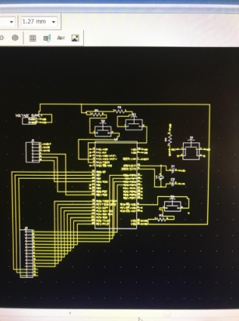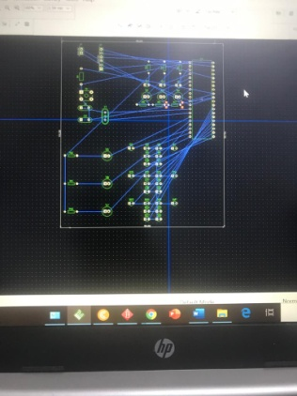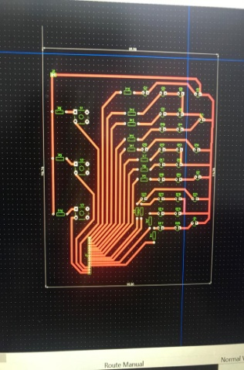

4 5

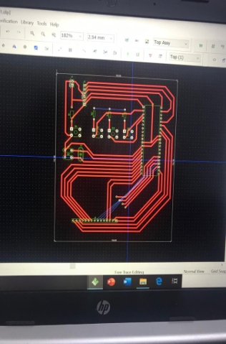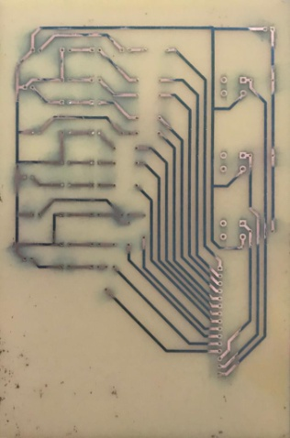

1. 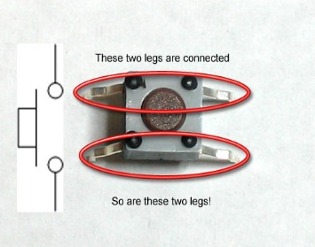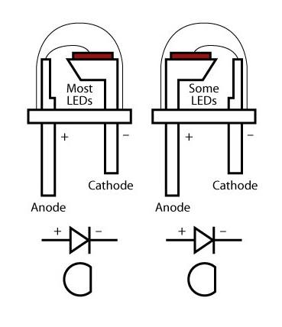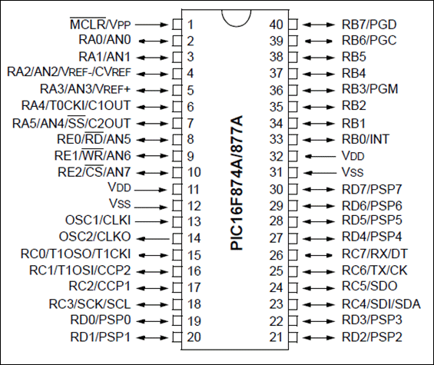 Data sheet للعناصر